CSE 385 Lab_03 & Exam 1 Review Spring 2019

The following is a list to keep in mind when you prepare for exam 1. The exam will be “open book” just like the quizzes you have taken. I suggest you do not back off studying for this. You will be challenged and have to know most of the material off the top of your head.

* Read and review all slides – anything in the slides (that we covered) is fair game on the exam.
* Review all quizzes in Canvas
* Anything I added during class – and said could be on the exam (like Hard Delete vs. Soft Delete)
* Be able to create a database via script
* Be able to create a table with correct Primary and Foreign keys **(we will cover Foreign Keys on Tuesday)**
* Be able to insert records into a table by letting the table generate its own primary key as well as inserting records into a table and setting your own primary key
* Day-02 Slides:
  + Know the different structures of a database
  + How to insert data into a table by turning on and off IDENTITY_INSERT
  + What’s the difference between DELETE FROM table and TRUNCATE table
* Chapter 3: Selecting data from a single table
  + The 4 clauses of the SELECT statement (SELECT…FROM…WHERE…ORDER BY)
  + Retrieving all or some columns
  + Controlling the number of rows that are returned from a SELECT statement
  + Using the BETWEEN – that is inclusive
  + Setting up a correlation name (alias) for columns – 2 ways to alias a column
  + Using built in methods
    - GETDATE()
    - LEFT()
    - CONVERT()
    - CAST()
    - DATEDIFF()
  + Know the difference between: NULL, IS NULL, IS NOT NULL, and ISNULL()
  + Know what DISTINCT, TOP(?), and TOP (?) PERCENT is used for
  + Know how to implement WITH TIES when using the TOP call. Requires ORDER BY
  + Know the logical operators: AND, OR, and NOT
  + Know the IN(…) and the LIKE(…) methods
  + Review how to use ORDER BY – this can be by column names and or column numbers and ASC / DESC
  + Using the OFFEST…FETCH NEXT… combination – this also requires ORDER BY
* Chapter 4: Selecting data from multiple tables
  + INNER vs OUTER JOINS
    - The terms “INNER” and “OUTER” are optional
  + You must know the syntax of setting up JOIN, LEFT JOIN, and RIGHT JOIN
  + Creating correlation names (alias) for tables
  + Know the difference between Implicit and Explicit syntax for joins
  + Understanding and implementing a self-join
  + The difference between a FULL JOIN and a CROSS JOIN
  + Using the UNION and UNION ALL
  + Know the syntax for using a date in a query
  + You should cover the Logical Query Processing Phase found on last page of chapter 4 slides
  + YOU ARE NOT REQUIRED TO KNOW:
    - EXCEPT
    - INTERSECT

The following questions relate to the StudentRentals database found on Canvas – The diagram below shows the relationship between the dB objects.

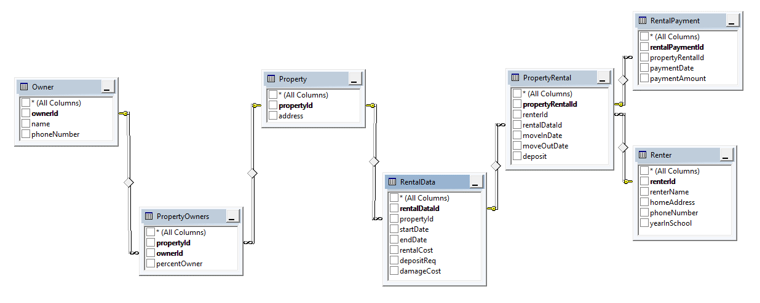

1. (49 records) Write the query that returns each property owned by an owner. Return the owner’s name, phone number, and the property’s address. Sort the list by address and then the owner’s name.
2. (3 records) Write the query that returns each renter that still owes a deposit. Return the renter’s name, property’s address, the amount of deposit the renter has paid, what the required deposit should be for the property, and the amount of deposit the renter still owes (user defined field called “depositOwed”). Sort the list by the renter’s name
3. (4 record) Write the query that returns each renter that still owes a deposit as well as the renters that paid too much deposit. Return the renter’s name, property’s address, the amount of deposit the renter has paid, what the required deposit should be for the property, and the amount of deposit the renter still owes owes (user defined field called “depositOwed”). Sort the list by the renter’s name. Note: your answer should be written so there is only 1 SELECT statement.
4. (15 records) Write the query that returns each renter that still owes a deposit, renters that paid too much deposit, and renters that paid the correct amount of deposit. Return the renter’s name, property’s address, the amount of deposit the renter has paid, what the required deposit should be for the property, the amount of deposit the renter still owes owes (user defined field called “depositOwed”), and a field called “status” that displays the appropriate text: “OK”, “Outstanding Account”, or “Refund Needed” . Sort the list by the renter’s name.
5. (5 records) Write an implicit query that returns the first 5 property address and owner’s name where the owner owns 100% of the property. Sort the list by the address and then the owner
6. (5 records) Assuming you have seen the first 5 rows listed in the previous question display the next 5 rows
7. (1 record) Write the query that will return all property addresses and renter’s name that are renting but not paid rent. Also include a user defined column called “status” and assign it “No Rent Paid”